2021 Canada International Gastronomy and Tourism Competition
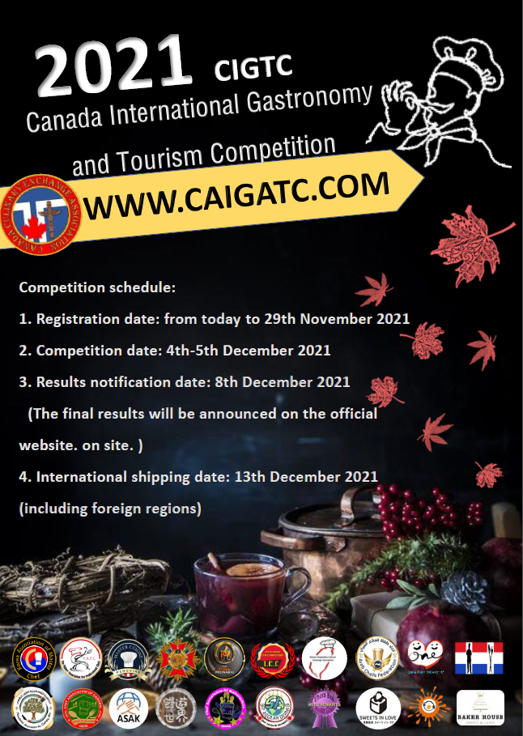
Organizer:
Canada Culinary Exchange Association

Co-organizer:
Palestine Association for Culinary Arts
Chef Association Of Garhwal ( India )
Korea’s Talented Person Association
Arab Chefs Federation
Chef Association Of Maharashtra （India）
Master Cuisine（PERU）
Club Mundo Culinario（ Colombia）
Korea Association of Master chefs
Korea Food Coordinator Association
Knead To Inspire (Singapore)
Sweets in love（Japan）

Due to coronavirus pandemic and epidemic preservation policy, also protect our health
and safety, the 2021 Canada International Gastronomy and Tourism Competition
has been transformed by holding on the internet.
- Organizer: Canada Culinary Exchange Association
- Co-organizer: Palestine Association for Culinary Arts, Chef Association Of Garhwal ( India ) , Korea’s Talented Person Association, World Association Of Master Chefs (Turkey ), The Future association For Professional Chefs（Israel）, Arab Chefs Federation, Chef Association Of Maharashtra （India）, Master Cuisine（PERU）, Club Mundo Culinario（Colombia）, Korea Association of Master chefs, Korea Food Coordinator Association, Knead To Inspire (Singapore), Coco's MantouFun（Malaysia）,Sweets in love（Japan）
- 2021 Canada International Gastronomy and Tourism Competition（BTGFIC）。
- Registered country: Belgium, Pakistan, Turkey, Israel, Korea, Taiwan, Australia, Peru, India, Arab, Japan, Malaysia, Singapore, Vietnam.
- .Registration fee: USD185 dollars per person for a competition (inclusive of international delivering fee), if you register more than 1 competition, then the fee will be USD125 start from the 2nd challenge. (inclusive of international delivering fee)
- .Competition categories: (A) cuisine display (B) baking display (C) International Renowned Chef Awards
- International Renowned Chef Awards Application: USD300 dollars per person
- Competition process： (1) Record the specified video (2) Provide the finished product picture (3) Provide the product description in English edition
Application form: Please refer to the last page.
九、Competition schedule:
1. Registration date: from today to 29th November 2021
2. Competition date: 4th-5th December 2021
3. Results notification date: 8th December 2021
(The final results will be announced on the official website. on site. )
4. International shipping date: 13th December 2021 (including foreign regions)
十、Sign up for the competition:
1.Please sign up for the competition via our official site（URL for registration）
English URL: https://forms.gle/va42PygRGK42PSSv8
2.Please send （1）registration form( refer to the last page)（2）remittance date and the last 5 digits of your account number to our mail address. THCEA2015@gmail.com

十一、LINE ID: @430umhpr
十二、Official website: https://www.caigatc.com/

INTERNATIONAL JUDGE
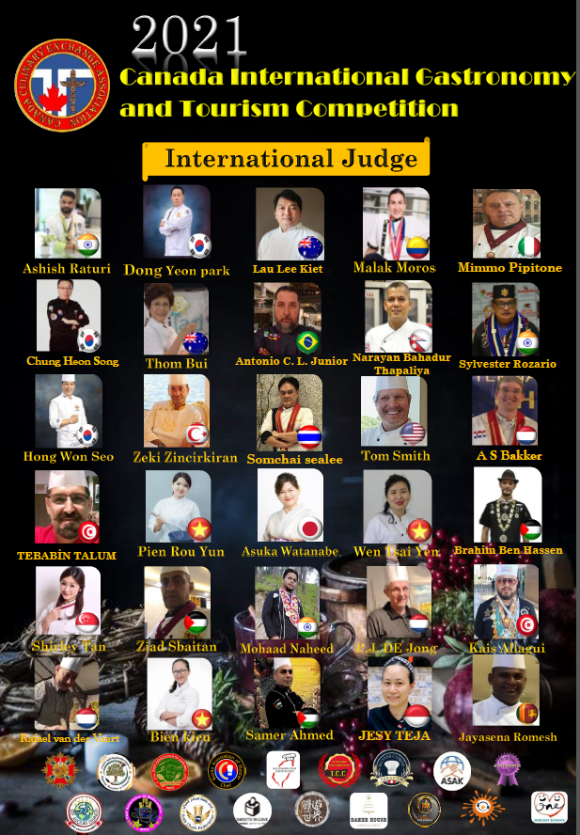

General rule
1. Each item you’ve provided to us will only be evaluated in that category.
2. The participants who have registered are not allowed to change competition categories, and the registration fees are non-refundable.
3. We reserve the right to cancel the eligibility for those whose entries are non-compliance.
4. The committee reserves the right to modify, add, or remove the portion of competition upon any force majeure.
5. All results of evaluation need to be accepted, any appeal of subjective factor are unacceptable.
6. Please be informed that registration will be failed by any incomplete registration process, and the you’ll get the notification if the registration process is successful.
7. English descriptions of menu need to be added in order to get evaluations from foreign reviews.
8. Winners are able to get the gold, silver and bronze awards. Also, awards are not available for those whose grades are not reach the criterion .
9. Please make sure that your video is available for viewing on YouTube, or you may lose a portion of grade for video.
10. Please read the rules of competition before you register this competition, all applicants shall be deemed to agree with the rules.
11. All entries need be made by yourself, outsourcing and purchasing ready-made are prohibited.
Details and Rules
a. Personal cuisine display ( A category )
1. The competition is only open to individuals.
2. All competitors need to comply with the final results of competition, any appeals of subjective factor are unacceptable.
3. All cuisine should be prepared for individual size, any menu or list must be typed in English. 4. All display food need surface-sizing except fried food and baked-dough.
5. Any types of cuisine are qualified to register the competition
A1. Main course 1 plates
A2. Appetizer 1 plates
A3. Banquet dishes 1 plates
Required information:
(1) Cooking process need to be contained in your video, and the video should last approximately 3 minutes. Scenes that recording the competitor who is cooking the cuisine should be shot in the video. You are allowed to edit the video or use your smart phone to shoot it, and please upload your video to YouTube and send us the link.
(2) Photos for cuisine: 3 photos from different sides. ( The first picture should be taken with the competitor.)
(3) Recipe in English: Ingredient, Methods of cooking and descriptions of concept should be contained. Scoring Criterion
Scoring Criterion:
Item | Score | Scoring Content
Difficulty, technical / Practical and technical | 0-50 | ＊Superb technique, precise and stable skill  ＊Sophistication of cuisine  ＊professionalism demonstrating
Proportion of weight and professionalism | 0-50 | ＊Proper portion, arrangement of staple food and non-staple food ＊professionalism demonstrating

names of competition | reviewing criterion
A1. Main course 1 plates | 1. Both meat and seafood are qualified.  2. portion control is necessary.  3. Vegetables, starch and sauce are still needed in this part.
A2 Appetizer 1 plates | 1. The contents in 1 plates should be different. (Both meat and seafood are qualified.)  2. portion control is necessary.
A3. Banquet dishes 1 plates | 1. Different type of foods in 1 plates, you don’t really need to cook the food which is really provided at restaurants.  2. he food whose practicality, skill and feasibility for running a restaurant should be considered in this part.  3. You should control portions and base the principle of consistency in this part.
※The competition names and reviewing criterions which motioned above are for reference only, the committee reserve the final right to modify.
※The committee reserve the final right to review entries and make decision according to rules and results, and will not accept any reveals
（二）Personal baking display （B Category）
1. The competition is only open to individuals.
2. All competitors need to comply with the final results of competition, any appeals of subjective factor are unacceptable.
3. All desserts should be prepared for individual size, any menu or list must be typed in English.
4. All foods must be made by edible ingredients.
B1. Display of decorating a fondant cake
B2. Display of mounting patterns on cake in Korean style
B3 . Display of Special shaped cakes
B4. .Art bread Display
B5. Delicate dessert Display
B6. Macaron Display
B7. Icing cookie Display
B8. Jelly flower Display
B9. Display of shaped steamed bun
B10. Sugar-craft Display
B11. Chocolate BONBON demonstration
B12. Display of pulled sugar
B13. Display of shaped Japanese dessert
Required Information:
(1) Cooking process need to be contained in your video, and the video should last approximately 3 minutes. Scenes that recording the competitor who is making the dessert should be shot in the video. You are allowed to edit the video or use your smart phone to shoot it, and please upload your video to YouTube and provide us the link.
(2) Photos of cuisine: 3 photos from different sides. ( The first picture should be taken with the competitor.)
(3) Recipe in English: Ingredient, Methods of cooking and descriptions of concept should be contained.
Scoring Criterion:
Criterion: | Scoring | Measure of Ability
Theme | 0-10 | ＊ Whether the product matches the theme or not ＊ Rate of achievement of whole design
Creativity/Uniqueness/Harmony of Color | 0-30 | ＊ Whether the creativity is being shown or not  ＊ Uniqueness of product  ＊ Harmony of color
Artistry | 0-30 | ＊ Artistry of visual aesthetic
Skill | 0-30 | ＊ Difficulty and delicateness

names of competition | reviewing criterion
B1. Display of decorating a fondant cake | 1. The competition should be proceeded in static mode individually.  2. The size of product should be within 45(W) x45(D) x60(H). 3. If you need base or acrylic cover, please prepare them by yourself.  4. All decorations of cake should be edible except stand.  5. The cake’s surface should be covered by marzipan , and 8-inch sphere cake should be located under surface. 。 (Using Styrofoam ball for replacement is acceptable.)
B2. Display of mounting patterns on cake in Korean style | 1. 8-inch sphere cake with no restrictions in style. (Using Styrofoam ball for replacement is acceptable.)  2. More than 2 styles of flower should be presented.  3. Color paste or other decorations need to be edible.
B3. Display of Special shaped cakes | 1. The competition should be proceeded in static mode individually.  2. The size of product should be within 45(W) x45(D) x60(H). 3.You can use sphere cake or Styrofoam ball to be your main body。  4.Decorations：no restrictions，but need to be edible. 5.Stands: Stands can not directly contact the cake if it’s inedible.。
B4. Art bread Display | 1.Art bread should be used as main ingredients.  2.The product should be presented by the craft which is suitable for it.  3.All ingredients should be edible, and inedible stuffing should not be contained in bread.  4. The size of product should be within 45(W) x45(D) x60(H).
B5. Delicate dessert Display | 1.Please divide plating desserts on 2 10-inch plates. 2.Decorations , tablecloth and lighting equipment need to be prepared by yourself.  3. inedible ingredients or banned additives should not be contained in your bread.
B6. Macaron Display | 1.You should demonstrate 4 types of creative Macarons, 3 Macarons for each type.  2.Decorations on Macarons should be edible, inedible adhesive is prohibited.  3.The area of container should be within 40(W) x40(D).
B7. Icing cookie Display | 1.4 types of cookies have to completely covered by icing , and there should be 3 pieces of cookie in the same pattern for each type.  2.Above 4 baking skills should be demonstrated in this part. 3. All decorations and color additives should be edible.  4. The area of container should be within 40(W) x40(D).
B8. Jelly flower Display | 1. There is no restriction on the form, but size should be 8 inch.  2.Height limit:6cm~8cm.  3.You must use edible color additive.  4.Please use jelly powder or gelatin.（Natural gum powder is prohibited. ）  5.Do not make any flower decorations on your jelly flower.
B9. Display of shaped steamed bun | 1. 4 types of steamed bun with no stuffing should be demonstrated in this part, and there shall be 3 steamed buns for each type.  2.weight limit for each steamed bun:110g-150g  3.You should use above 2 colors to make the dough. (Please use natural pigment. )  4.There is no restriction on the form.
B10. Sugar-craft Display | 1. There is no restriction on the theme.  2. The size of product should be within 40(W) x40(D).  3.You should use 8 artificial flowers with leafs, but there is no restriction on flower types.  4.You can use any edible ingredients such as gum paste, wafer and chocolate. You can use iron wire to make stand but do not let them protrude from the product.  5. Using such pistils, tapes , ribbons or non-edible container is allowed.
B11. Chocolate BONBON Display | 1.You should choose chocolates as main ingredient to demonstrate your craft.  2. 5 types of chocolate dessert should be demonstrated in this part, and there shall be 4 desserts for each type.  3. There is no restriction on the theme.
B12. Display of pulled sugar | 1. You should choose sugar as main ingredient to demonstrate your craft.。  2. All ingredients should be edible. Also, edible additive is allowed to use in this part.  3. The size of product should be within 90(W) x90(D) x160(H).
B13. Display of shaped Japanese dessert | 1.6 types of Japanese dessert which weighs 30g-50g should be demonstrated in this part, and there shall be 2 desserts for each type.  2. Decorations on dessert should be edible, inedible adhesive is prohibited.  3. The area of container should be within 40(W) x40(D).
※The competition names and reviewing criterions which motioned above are for reference only, the committee reserve the final right to modify.
※The committee reserve the final right to review entries and to make decision according to rules and results, and will not accept any reveals.

Competition Awards
Ranking | Score | Remark
Gold medal | 91~ 100 | Medal and Certificate
Silver medal | 81~ 90 | Medal and Certificate
Bronze medal | 71~ 80 | Medal and Certificate
Competitors who don’t reach score 70 will not receive any medal or certificate.
International Renowned Chef Awards Application

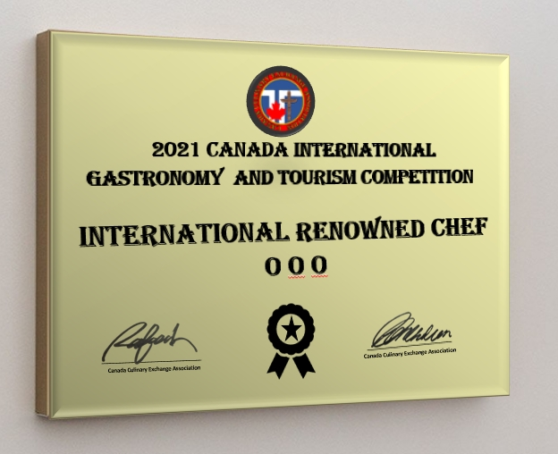

Competition Item（ Multiple selections accepted）
A1.Main course 1 plates
A2.Appetizer 1 plates
A3.Banquet dishes 1 plates
B1.Display of decorating a fondant cake
B2.Display of mounting patterns on cake in Korean style
B3.Display of Special shaped cakes
B4.Art bread Display
B5.Delicate dessert Display
B6.Macaron Display
B7.Icing cookie Display
B8.Jelly flower Display
B9.Display of shaped steamed bun
B10.Sugar-craft Display
B11.Chocolate BONBON Display
B12.Display of pulled sugar
B13.Display of shaped Japanese dessert
C.International Renowned Chef Awards Application
1. Please sign up for the competition via our official site.（URL for registration）
English URL https://forms.gle/va42PygRGK42PSSv8
2. Please send （1）registration form( refer to the last page)（2）remittance date and the last 5 digits of your account number to our mail address THCEA2015@gmail.com
Official website: https://www.caigatc.com/

Application Form (Please Fill Out In English)
Name: | Competition Item: | Product Name:
Ingredients:

Cooking Methods:

Product Philosophy:

Please upload the video to the youtube and refer to the following website:

3 pictures of the product:

★You need to separately fill out the form by each item; if you want to apply for more competitions, you need to separately fill out the forms.
★If the form is not enough for you to use, please prolong the form by yourself.

 |  | International Renowned Chef Awards Application
Passport name |  |  | passport ID card number
Company name and position
International address
telephone |  |  | EMAIL
Work experience and award winning experience
Photo

